|  |  |
| --- | --- |
| **Assignment Date** | 26 September 2022 |
| **Student Name** | Jotheeswaran S |
| **Student Roll Number** | 731619104022 |
| **Maximum Marks** | 2 Marks |

# Solution:

1. **LOCATION COLOURED BY SALES? SOLUTION**

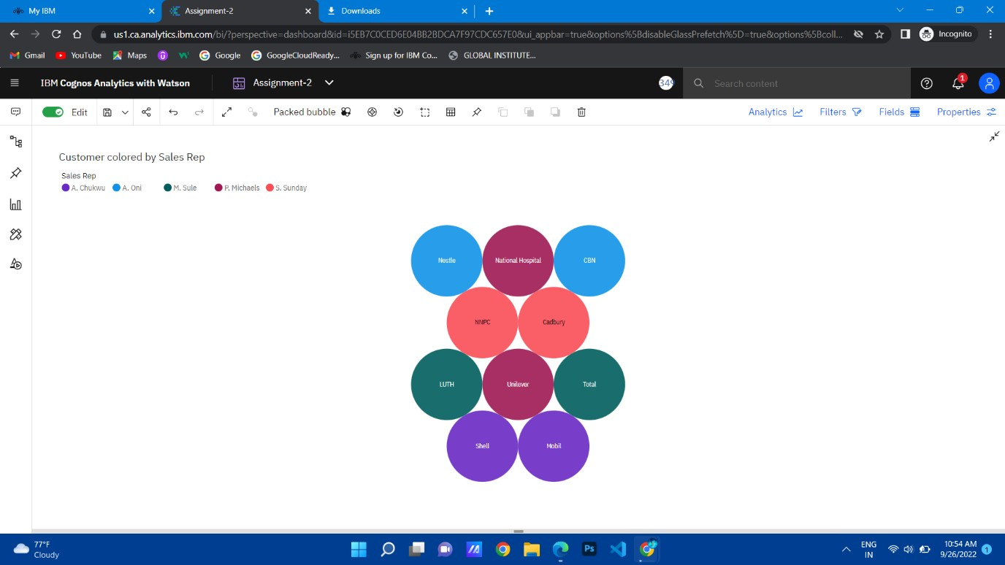

1. 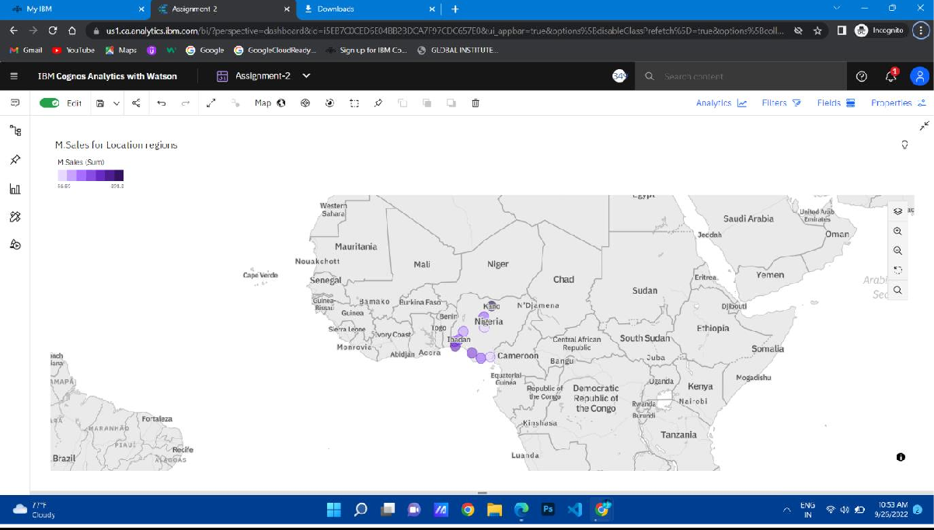**INVERTORY STOCK BY WARE HOUSE? SOLUTION**
2. **ACTUAL AND INVENTORY STOCK BY MONTH? SOLUTION**

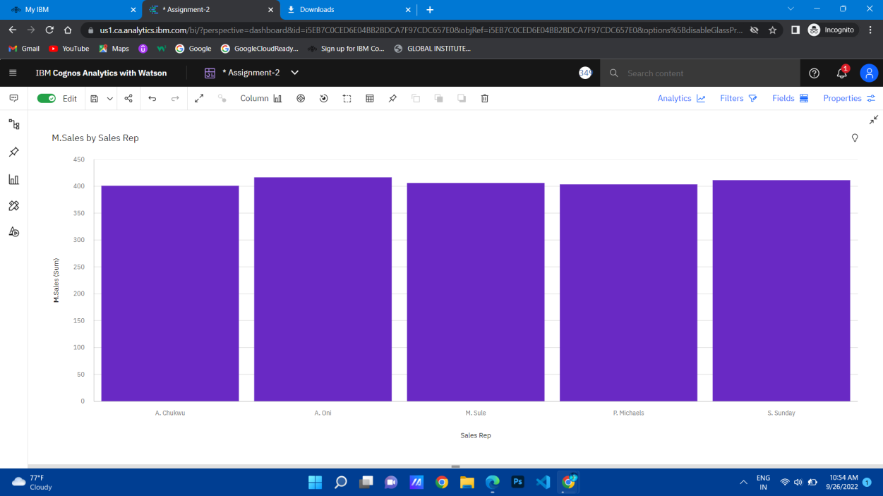

1. **SUPPLIER SIZED BY INVENTORY STOCK? SOLUTION**

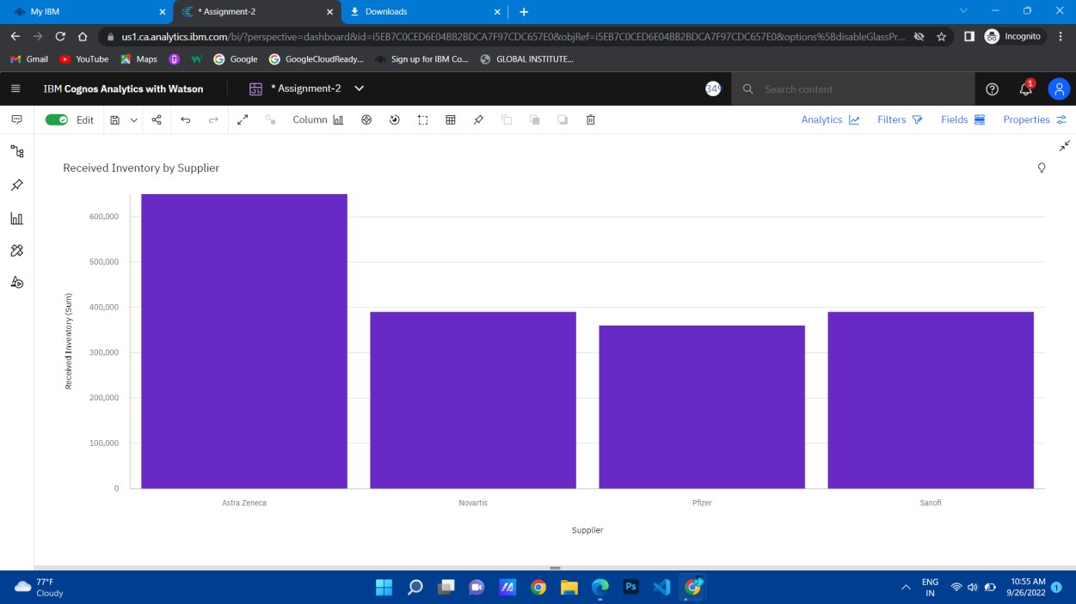

1. **CUSTOMER BY MONTH COLOURED BY SUPPLIER? SOLUTION**

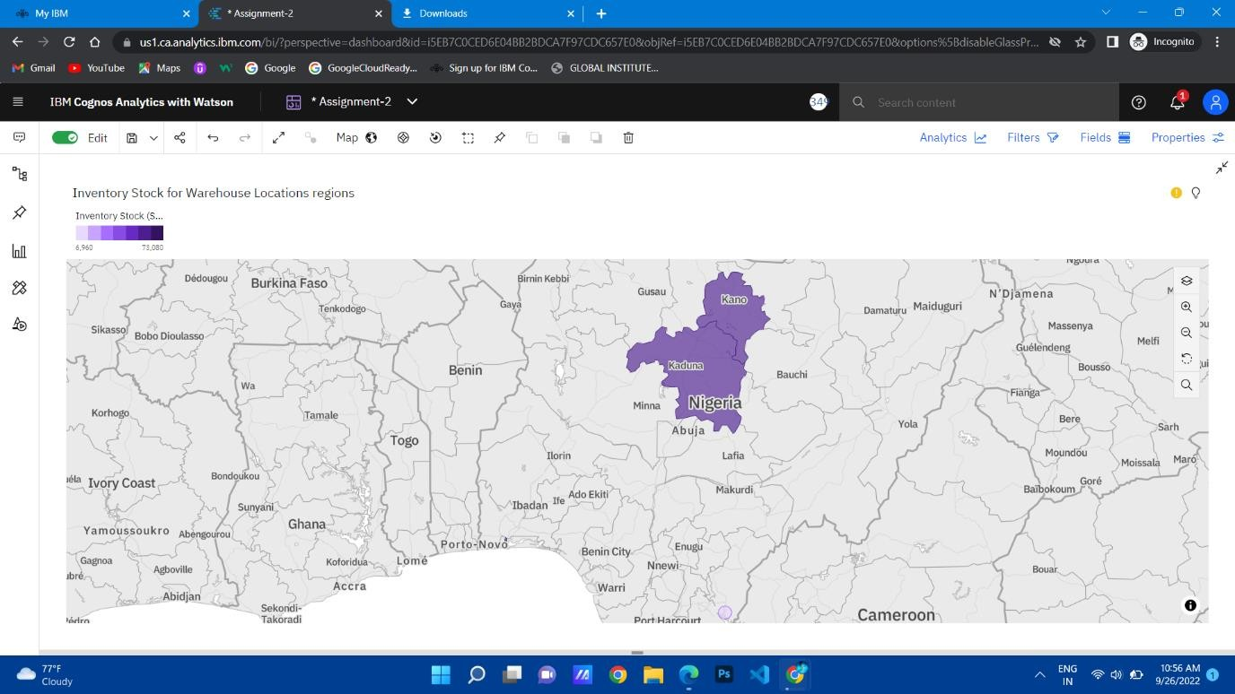

1. 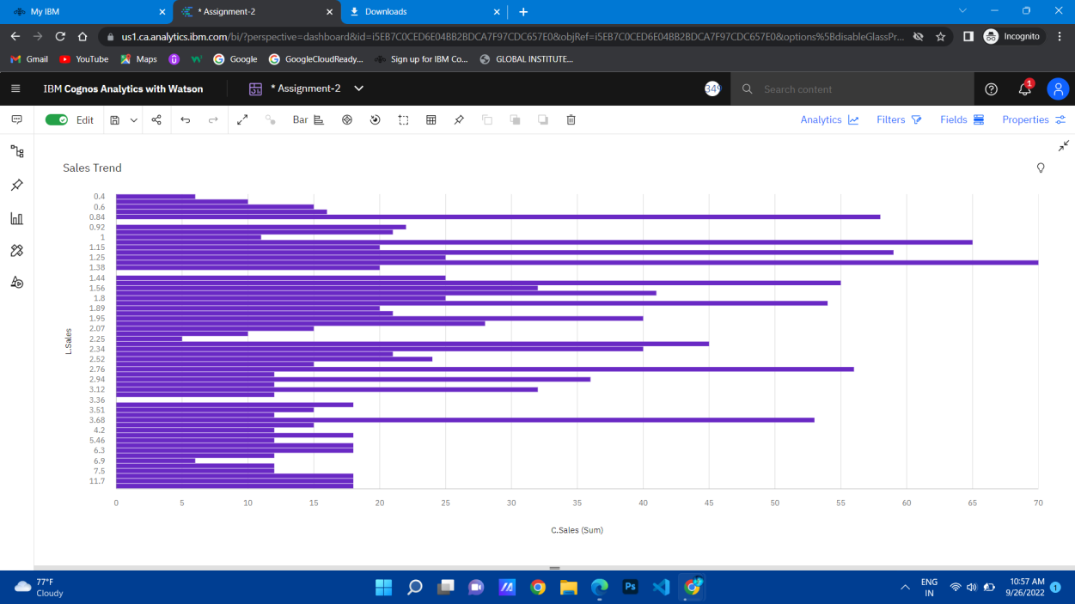**SALES BY CUSTOMER? SOLUTION**
2. **SALES BY SALES REP? SOLUTION**

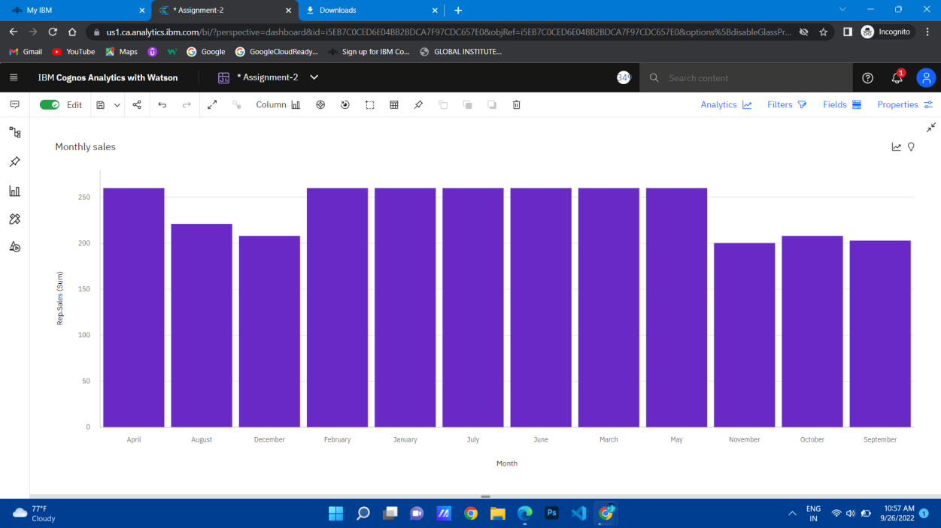

1. **TARGET FOR SALES REP?**

SOLUTION

